# Shen xiangyu

# 2020110057

# A design of intended additional features

1. Used jQuery to integrate some dynamic content:

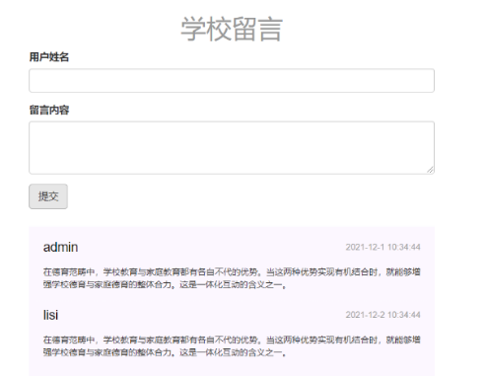

This is a school message function made with jQuery. Click the submit button, and the user's name, message content and submission time will appear below. More importantly, you can keep submitting as long as you don't refresh the page. You can synchronize the current time using the new Date () function in jQuery.



This is a back to top function made with jQuery. This feature is set up because some pages require scrolling up and down. This function uses the fade in and out effect of jQuery.





This is a numeric increment effect created by jQuery. The jQuery plugin countup and Waypoints are also needed for this functionality.

2. Used JavaScript to integrate some dynamic content:

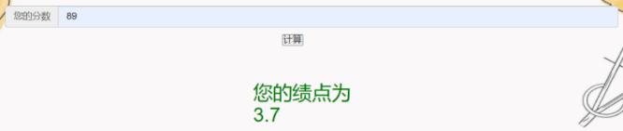

This is a JavaScript generated grade point transfer function. By entering your score you can convert it into a corresponding GRADE point. Your GPA will be displayed below.

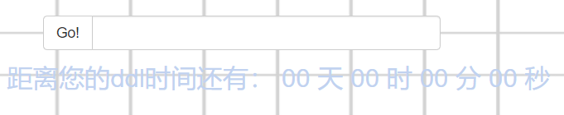

This is a JavaScript countdown system. After you have entered the DDL time in the box, click GO! Button and the system will tell you how much time the DDL has left. However, note that your DDL can only be entered once, and a second entry requires a page refresh. If you enter a past time, it will remind you that the DDL time has passed.

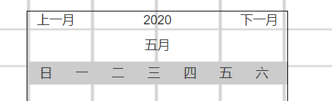

This is a calendar system made by JavaScript. When you click on the input box, the full calendar will be generated

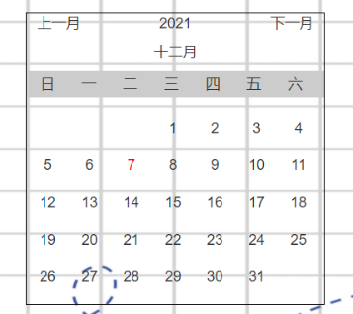

This calendar system uses JavaScript's new Date () function to synchronize today's Date. Also when you click on the previous month or next month the jump will occur.



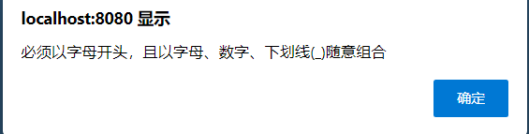

When you click on the account for input, the webpage will remind you to enter the format, and the account will jump up and drop after input.

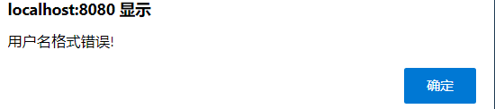

If your input format is incorrect, you will be notified

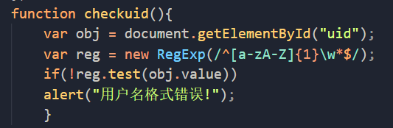

In order to determine whether the format is correct, regular expressions are used to determine the method.

3．a wireframe models

交大首页：

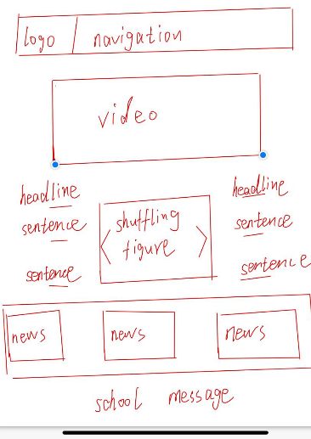

学校简介

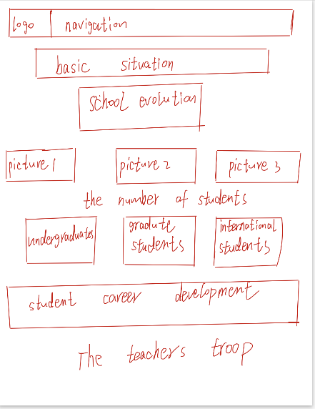

GPA转换系统

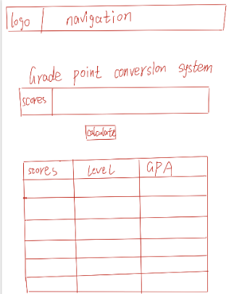

自习室：

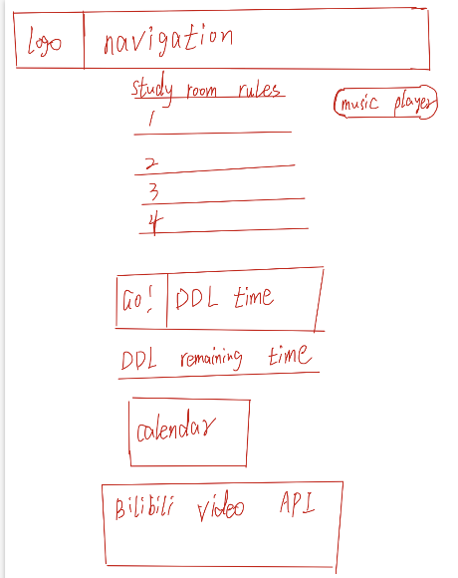

登陆界面：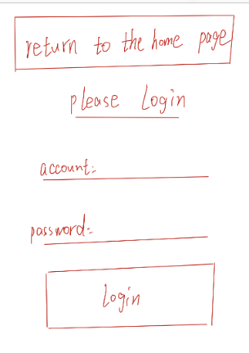

4. integration with some external web service:

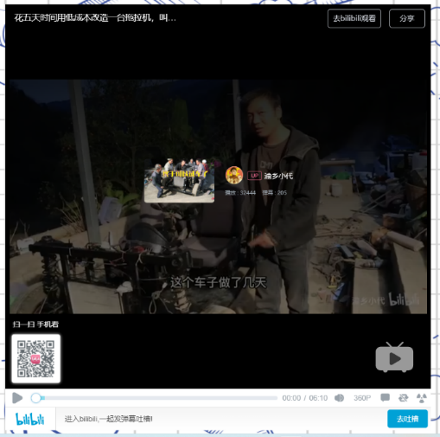

In the "study room" page, I added bilibili external network service. In the process of self-study, if you feel tired, you can watch videos to relax.

5. responsive web:

To create a responsive network structure, I used the Bootstrap framework. It can be adapted to mobile terminals through the grid system of Bootstrap. At the same time, I also used the bootstrap rotation chart, table system, input box group and navigation bar.



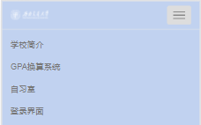(Make the navigation bar adaptive on the mobile)

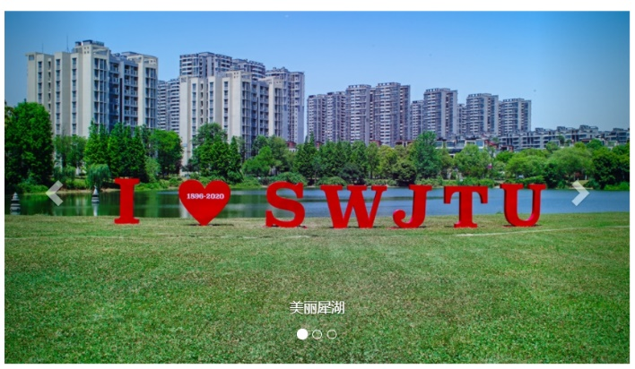(An adaptive carousel graph)

(Adaptive input box)

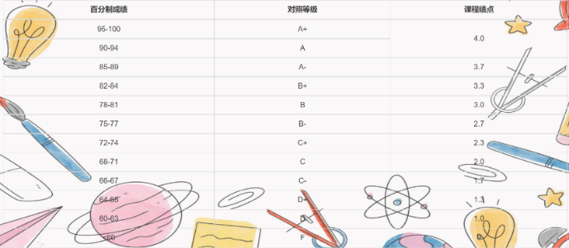(Table that can be adapted

(Adaptive input box)

6. Html5 Advanced Features

I used the WEB storage function of HTML5, which can save the data of the whole website for a long time. The saved data does not expire until manual removal.

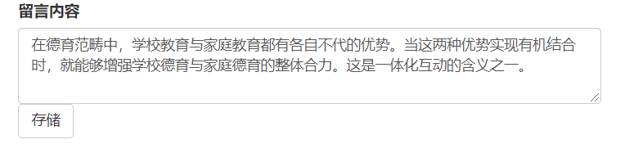

Here I stored the message content, and each student's message can be modified on this basis, greatly improving the efficiency.

7. Improvements from the last assignment.

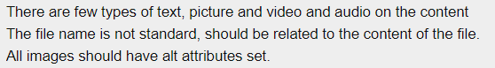

I have improved the shortcomings of the last assignment:

1. I added audio and video capabilities to my web page
2. I modified all the file names to fit the theme
3. I added alt attributes to all the images

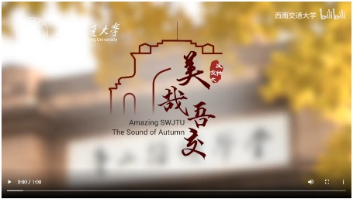**video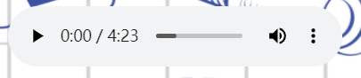 audio**

# An evaluation

## 1 Evaluation of this assignment:

1. Change of the navigation:

Original: 

New: 



The navigation bar is adaptive and the new navigation bar is more concise

1. The addition of the rotation chart

Original:



New:

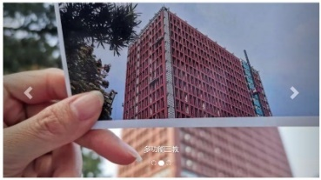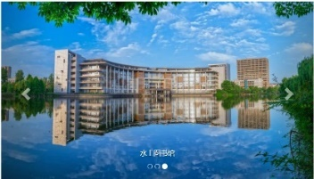

The addition of the wheel map makes the page more beautiful and adaptive

1. The increase in school message boards: Click the submit button, and the user's name, message content and submission time will appear below.

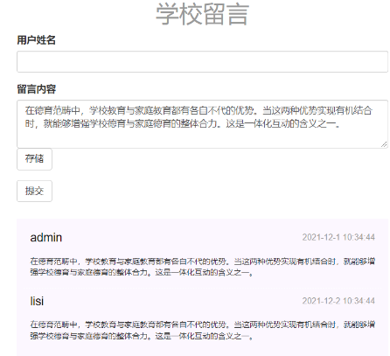

1. Added back to top feature:

Button to return to the top, also works, click the button will quickly return to the top of the page



1. Add GPA conversion system

GPA conversion system can help you to change GPA, the only drawback is too simple function

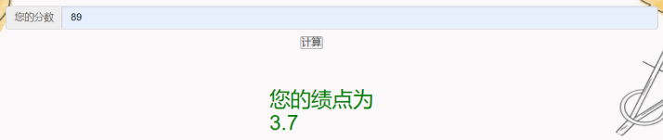

1. Add DDL function

The DDL function in "Study Room" can work normally, but it should be noted that the DDL time input needs to follow a certain format





1. Add a calendar:

When the text box is clicked, a calendar appears, but the calendar can only be manually adjusted and cannot be quickly jumped to the specified

time.



1. When clicking on the account, it will remind you to enter the format, and if the format is wrong, it will also prompt you.





1. External Network Service: I added bilibili external network service. In the process of self-study, if you feel tired, you can watch videos to relax.



## Testing of new features

1. The navigation bar：The navigation bar can be clicked to jump to other pages, and the realization of self-adaptation





1. Shuffling figure：It can jump in a certain amount of time



1. school message boards: Functionality can be fully implemented and data can be saved

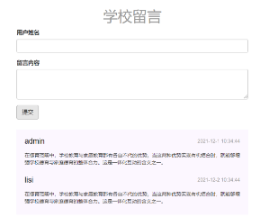

4. Added back to top feature: This button works fine



1. All of the following functions can be tested and run:









# Reference:

1.Tsinghua university, viewed 2 December 2021, [pic11.png (580×372) (tsinghua.edu.cn)](https://www.tsinghua.edu.cn/image/pic11.png)

2.Tsinghua university, viewed 2 December 2021, [pic22.png (580×372) (tsinghua.edu.cn)](https://www.tsinghua.edu.cn/image/pic22.png)

3.Tsinghua university, viewed 2 December 2021, [pic33.png (580×372) (tsinghua.edu.cn)](https://www.tsinghua.edu.cn/image/pic33.png)

4.Peking university, viewed 2 December 2021, [bg17.jpg (1920×634) (pku.edu.cn)](https://www.pku.edu.cn/Public/static/themes/image/bg17.jpg)

5. Peking university, viewed 2 December 2021, [s5de534a25563e.png (80×94) (pku.edu.cn)](https://www.pku.edu.cn/Uploads/Picture/2019/12/02/s5de534a25563e.png)

6. Peking university, viewed 2 December 2021, [s5de512ca05308.png (92×92) (pku.edu.cn)](https://www.pku.edu.cn/Uploads/Picture/2019/12/02/s5de512ca05308.png)

7. Peking university, viewed 2 December 2021, [s5de5132035b0c.png (94×94) (pku.edu.cn)](https://www.pku.edu.cn/Uploads/Picture/2019/12/02/s5de5132035b0c.png)

8. Peking university, viewed 2 December 2021, [s5de5133d30a1e.png (84×88) (pku.edu.cn)](https://www.pku.edu.cn/Uploads/Picture/2019/12/02/s5de5133d30a1e.png)

9.Southwest jiaotong university, viewed 2 December 2021, [jbqk.jpg (1298×459) (swjtu.edu.cn)](https://www.swjtu.edu.cn/images/ny/jbqk.jpg)

10. Southwest jiaotong university, viewed 2 October 2021, [eb7c884f-cd2d-4943-a0f8-867d397e56b6.jpg (600×365) (swjtu.edu.cn)](http://xgservice.swjtu.edu.cn/service/uploadserver/WebFiles/images/newcf/202012/eb7c884f-cd2d-4943-a0f8-867d397e56b6.jpg)

11. Southwest jiaotong university, viewed 2 October 2021, [bg6.jpg (1296×263) (swjtu.edu.cn)](https://www.swjtu.edu.cn/images/ny/bg6.jpg)

12. Southwest jiaotong university, viewed 2 October 2021, [logo.png (292×76) (swjtu.edu.cn)](https://www.swjtu.edu.cn/images/logo.png)

13. Southwest jiaotong university, viewed 2 October 2021, [西南交通大学 三教 - 国内版 Bing images](https://cn.bing.com/images/search?view=detailV2&ccid=WeEF1mre&id=9B0035366448234D653A555ACA325BEFCBD39A72&thid=OIP.WeEF1mre03zIF4UP-BqlOgHaFj&mediaurl=https%3a%2f%2ftse1-mm.cn.bing.net%2fth%2fid%2fR-C.59e105d66aded37cc817850ff81aa53a%3frik%3dcprTy%252b9bMspaVQ%26riu%3dhttp%253a%252f%252fp4.itc.cn%252fq_70%252fimages03%252f20201123%252f3b696eef603d47e0aff13937d1406764.jpeg%26ehk%3dLOxX3b1H9MfAZXBhOlDJCsdN2Hadq8R1mDbI9BjIdXQ%253d%26risl%3d%26pid%3dImgRaw%26r%3d0&exph=810&expw=1080&q=%e8%a5%bf%e5%8d%97%e4%ba%a4%e9%80%9a%e5%a4%a7%e5%ad%a6+%e4%b8%89%e6%95%99&simid=608022860800489233&FORM=IRPRST&ck=2719DA819AA8165A7D8EA19D51315C7C&selectedIndex=5&ajaxhist=0&ajaxserp=0)

14. Educational Administration network of Southwest Jiaotong University, 2021, [西南交通大学 (swjtu.edu.cn)](https://www.swjtu.edu.cn/).

15.Southwest Jiaotong University faculty, 2021, [西南交通大学_百度百科 (baidu.com)](https://baike.baidu.com/item/%E8%A5%BF%E5%8D%97%E4%BA%A4%E9%80%9A%E5%A4%A7%E5%AD%A6/166403)

16. Southwest Jiaotong University School evolution,2021, [西南交通大学_百度百科 (baidu.com)](https://baike.baidu.com/item/%E8%A5%BF%E5%8D%97%E4%BA%A4%E9%80%9A%E5%A4%A7%E5%AD%A6/166403)

17. Employment situation of Southwest Jiaotong University in 2020,2020, [西南交通大学2020届毕业生就业质量报告_腾讯新闻 (qq.com)](https://new.qq.com/omn/20210415/20210415A01AGC00.html)

18. Bootstrap, <https://www.bootcss.com/>

19. jQuery, <https://jquery.com/>

20. JavaScript, <https://www.javascript.com/>

21. jquery.countup.js: <https://inorganik.github.io/countUp.js/>

22.jquery.waypoints.js: <http://imakewebthings.com/waypoints/>

23.Bilibili: <https://www.bilibili.com/video/BV1WL4y1W7Jh?share_source=copy_web>

# A description of the role of a client and server in the world wide web.

## The internet and the web

The internet and the Web are two distinct things, although the two are often used synonymously. The internet is a massive network of networks. It is the physical infrastructure that connects users together. This physical infrastructure includes switches, routers and satellite links (to name a few). The internet is a global network that allows any computer on the network to communicate with any other computer. The Web is a way of accessing information that is stored on devices connected to the internet. It is a set of protocols and services that make sharing information easy. For the case of HTML documents, the protocol used is HTTP. This protocol facilitates the requesting of resources stored on devices connected to the internet. HTML supports the linking of documents. One HTML document will link to another and in turn will point to another. This linking structure gives rise to the name "the Web". The structure of the Web can be likened to a spiders web, a huge collection of documents connected together by strands of silk. While most of the general public primarily use the internet to browse web pages, there is much more to the internet than just the Web. The internet is used to transfer research data, to synchronise clocks, to stream video and audio, and more. In general the internet can be used for any task which involves the communication of data from one computer to

## The architecture of the internet

As mentioned before, the internet is the physical infrastructure that facilitates the transfer of data from one computer to another. Although this module does not intend to teach networking, it is essential to have a fundamental understanding to be able to understand how the Web works. The internet is made up of links, switching and routing infrastructure and computers. The links that make up the internet can take many different forms. Some are copper - using electric signals, some are glass (fibre optic) - using light, and some use electromagnetic radiation to transfer data. Although the medium used by these links is different, their purpose is the same: to transport data from one endpoint to the next. The endpoints of these links are either computers or switching and routing infrastructures. Let us consider the purpose of switching and routing infrastructure. The transmission of data on the internet can be likened to sending a letter through the post. A message gets written and gets an address written on the envelope. The letter is then posted and enters the mail system. The messages is sent through a series of post offices, and at each step the letter gets closer to its destination. At the post office the letter gets sorted and forwarded to the next post office until eventually the post office can deliver it to the door of the recipient. In this analogy the letter is the packet of data: the roads that carry the letters between post offices are the links, the post offices are switches and routers and the sender and receiver of the letter are

## 3. The architecture of the web

The Web is the interconnected collection of documents available on the internet. The Web is made up of individual web pages which 'cluster' together to form web sites. Between pages there are links which allow users to navigate the web of documents. The type of the documents linked to in the 2 web can be anything. Usually these documents are HTML documents which contain links to other documents. The Web has evolved since its conception, but the principles are mostly the same. The web uses a client-server model. That is, there are computers on the internet whose sole task is to serve webpages that are requested by other computers. A computer on the internet that serves webpages is called a web server. A machine that requests pages from a web server is called a client, more specifically we refer to the specific application that is running on the client that makes the request for webpages as a web browser. The responsibility of a web browser is to request webpages from the server and to display them for the user. There are also automated clients that request webpages that will not be displayed to users - these are called bots. The purpose of such bots is to perform data

## 4.Different types of relations between HTML documents.

A Document Type Definition (DTD) is the specification by which HTML documents are classified into different categories. Don't let the word 'categories' make you nervous thinking that there are so many different types of categories of HTML documents out there. There are actually only three.

There are three document type definitions in HTML. Each document type definition specifies what type of document an HTML document will be.

Transitional - For HTML documents that use deprecated elements or attributes.

Frameset - For HTML documents that use frames (can also include deprecated elements or attributes like the transitional document type).

Strict - For HTML documents that include no deprecated elements or attributes, and no frames.

Every HTML document you create will fall into one of the above three categories.

## 5. What is a Client?

A client is a computer hardware device or software that accesses a service made available by a server. The server is often (but not always) located on a separate physical computer.

## What is a Server?

A server is a physical computer dedicated to run services to serve the needs of other computers. Depending on the service that is running, it could be a file server, database server, home media server, print server, or web server.

## The difference of the client and the server

In computing terminology, both “client” and “server” refer to computers that are used for different purposes. A client is a small computer that accesses a server through a network. For example, in an organization, an employee logs in to the client machine to access the files and applications running on a server machine. This two-tier architecture is also known as client-server architecture which mainly focuses on the division of labor in an organization. A server machine is a large-capacity computer that can store a wide variety of files such as application and data files. There are various types of servers, such as; application server, file server, web server, database server, print server, proxy server, game server, standalone server, etc. A client can be classified into fat, thin, and hybrid. A fat client supports both local storage and local processing. A thin client is a less powerful machine with minimum hardware installed. It usually utilizes the resources of a host machine and relies on the server to perform any data processing. The primary job of a thin client is just to graphically display the images provided by an application server. A hybrid client processes locally but relies on the server for data storage.

Some application servers may require users to log in from their client machines in order to access specific applications utilizing the client-server architecture. The client machines can not only access the applications and data files, but they can also use the processor of the server to perform certain tasks without having to add any additional hardware resources to the client machine.

The client computer usually contains more end-user software than the server computer. A server usually contains more operating system components. Multiple users can log into a server at the same time. A client machine is simple and inexpensive whereas a server machine is more powerful and expensive.

The main difference between a client machine and a server machine is in its performance. The client machines are considered optimal for applications which require speedy start-up times. A server machine is considered optimal for applications where the emphasis is more on performance.

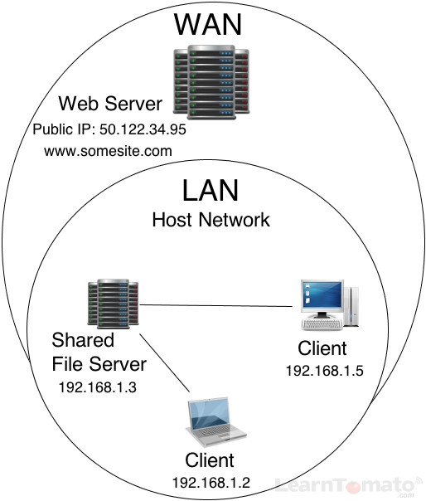

## Summary of the difference

1. A client machine is a small computer with a basic hardware configuration whereas a server machine is a high-end computer with an advanced hardware configuration.

2. A client is a simple and less powerful machine whereas a server is a powerful expensive machine.

3. A client is used for simple tasks whereas a server is used for storing huge datafiles and applications.

4. A server delivers high performance compared to a client machine.

5. A server supports simultaneous, multiple user log-ins whereas a client supports a single user log-in at a time.

# Description of HTTP

## The format of the HTTP request

An HTTP request contains a series of lines that each end with a carriage return and a line feed, represented as either .<CR><LF> or \r\n

The first line of a request (the message line ) contains the HTTP method and target. For example, a message line for a GET request contains the keyword GET and a string that represents the object that is to be fetched, as shown in the following example:

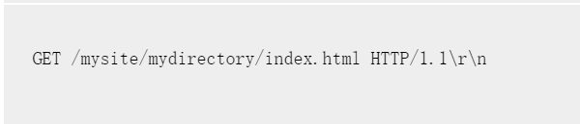

The rest of the request contains HTTP headers, including a required Host header and, if applicable, a message body. The request ends with a bank line (an extra ).<CR><LF> or \r\n. Following is an example of a request:

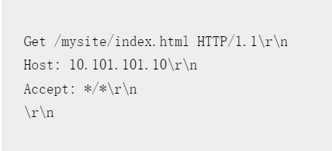

## The format of the HTTP response.

An HTTP response contains a status message, response HTTP headers, and the requested object or, if the requested object cannot be served, an error message. Following is an example of a response:

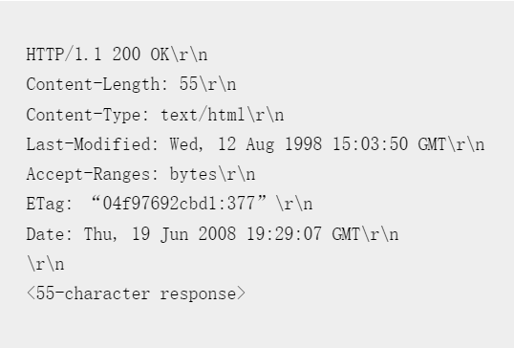

## HTTP verbs:

HTTP verbs tell the server what to do with the data identified by the URL. The HTTP method is supplied in the request line and specifies the operation that the client has requested. If you're going to follow the REST architecture and the HTTP protocol, you must choose from the verbs available in that protocol, the primary or most-commonly-used HTTP verbs are POST, GET, PUT, and DELETE.

These correspond to create, read, update, and delete (or CRUD) operations.

Using HTTP verbs

**GET**

This method is used to retrieve a representation of a resource. A GET request is considered safe because as HTTP specifies, these requests are used only to read data and not change it.

So in short there are no side effects and GET requests can be re-issued without worrying about the consequences.

The disadvantage of GET requests is that they can only supply data in the form of parameters encoded in the URI or as cookies in the cookie request header.

For example: Displaying your registered account details on any website has no effect on the account. If you are using Internet Explorer you can refresh a page and the page will show information that resulted from a GET, without displaying any kind of warning. We have also other HTTP components like PROXIES that automatically retry GET requests if they encounter a temporary network connection problem.

Tasks that you can do with GET requests are:

You can cache the requests

It can remain in the browser history

You can bookmark the requests

You can apply length restrictions with GET requests

It is used only to retrieve data

**POST**

POST is used when the processing you wish to do on the server should be repeated or when creating a new resource or for a POST to the parent when the service associates the new resource with the parent or for assigning an ID, etcetera. It is used to create new resources. For some resources, it may be used to alter the internal state. For others, its behavior may be that of a remote procedure call. If you try to refresh a page while using a POST request, then you will get an error like page can't be refreshed. Why? Because the request cannot be repeated without explicit approval by the user.

Example: The best example of a POST request I must say is when the user submits a change and then uses a 302 redirection (Code redirection details you will find later on this article) to change to a GET that displays the result of the action as the new updated value.

Some important points about POST requests:

Data will be re-submitted

It cannot be bookmarked

It cannot be cached

Parameters are not saved in browser history

No restrictions. Binary data is also allowed

Data is not displayed in the URL

**PUT**

PUT is used to create a resource, not in a general case but when the resource ID is chosen by the client instead of by the server, then only PUT is used. Simply PUT updates data in the repository, replacing any existing data with the supplied data.

For example: Suppose we wanted to change the image that we have something already on the server, So, we just upload a new one using the PUT verb.

Some good points of PUT requests are:

It completes as possible

It's as seamless as possible

Easy to use via HTML

It should integrate well with servers that already support PUT

## HTTP error codes

HTTP status codes are responses issued for a client’s request made to a server. For example, when your client (your web browser) tries to connect to your [WordPress](https://themeisle.com/blog/what-is-wordpress/) site (the server).

Based on how the request is handled, the server shows different responses. These responses include redirects, server errors, client errors, and others as such. HTTP error codes are not part of web pages; instead, they are responses from servers about how the request is handled.

Not all HTTP status codes indicate errors. For example, some just communicate that a page has been moved, either permanently or temporarily. But if you are experiencing errors, the HTTP error codes that you see will help you figure out what the problem is.

## Seven most common HTTP error codes and status codes

### “401 Unauthorized”

First on our list of HTTP error codes is 401. A 401 message means the server received an unauthenticated request.

In this error, a message announces that the page couldn’t load because of invalid credentials for whatever reason.

### “404 Not Found”

A 404 status code is a common HTTP error code on the internet. This HTTP response is generated when a page the user is looking for cannot be found on the server. There could be multiple reasons behind 404 occurrences. Perhaps because the webmaster has deleted the page or the URL you have entered is incorrect (since it’s a client-side error).

### “500 Internal Server Error”

A 500 Internal Server Error is a generic error that displays when something is wrong with your server. Because it’s a generic error message, there are a number of different causes including issues with WordPress plugins, PHP issues, database problems, and more.

### “502 Bad Gateway”

Unlike other HTTP error codes, 502 is different. A bad gateway occurs when one server on the internet receives an invalid response from another server. A 502 HTTP status code will be tacked on a screen when the server takes longer than expected to complete a request.

### “301 Moved Permanently”

An HTTP 301 is when a specific webpage is permanently moved to a different [URL](https://themeisle.com/blog/what-is-a-website-url/). It’s not an error per se, but it does communicate important information.

It can be on a page-level where you get pointed on another similar post (or even homepage for that matter) or a domain level.

### “302 Found”

This HTTP status code is similar to the 301, but it is used for a temporary redirect. This response tells Google that the page is moved temporarily and will be back to the original URL at some point. If done correctly, it will redirect the user to another URL in a couple of seconds.

### “410 Gone”

This 410 Gone error is similar to the 404 response. Think of this as a permanent 404. When a webmaster decides to remove a post or page forever or republish it on another site, they can use this code.

A 410 response tells Google the requested resource is permanently removed from the internet and will not reappear. This makes it easier to get the page de-crawled or de-indexed from Google.

## The order of events in an HTTP request.

1. Begin Request
2. Authenticate Request
3. Authorize Request
4. Resolve Request Cache
5. Acquire Request State
6. PreRequest Handler Execute
7. Post Request Handler Execute
8. Release Request State
9. Update Request Cache
10. End Request

# Comparison of html and CSS

1. CSS describe the presentation of a web page:

CSS is the style sheet language for describing web pages’ presentation and design, including colors, fonts, and layouts. It is mainly designed to enable the distinction between presentation and content, including colors, layouts, and fronts.

For example:

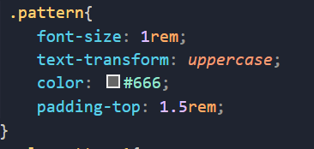**(CSS)**

**(HTML)**

2. CSS can be used in different types of devices, like large or small screens and printers. It is independent of HTML and can be used with any XML-based markup language. The World Wide Web Consortium mainly maintains the CSS specifications. CSS rule-set consists of a selector and a declaration block. For example:

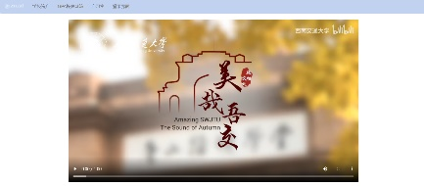(Larger screens)

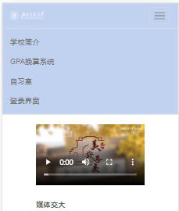(Small screens)

3. Style sheet:

The basic idea behind CSS is to separate the structure of a document from the presentation of the document. HTML is meant for structure. It was never intended for anything else. All those attributes you add to style your pages were added later as the viewing public demanded it. All those additions though make HTML clumsy and work against it’s main purpose of structuring a document. HTML is there to let a browser know that this block of text is a paragraph and that block of text is a heading for this paragraph.

Using cascading style sheets generally leads to less code behind your web pages which helps the downoad times of a page. When browser sees a table in your code it needs to read through all your code twice. Once to understand the structure of the table and once again to actually display the content within the table. The extra time slows up your page. Using tables in the layout of a web page generally leads to a greater use of images on that page. Images are often the heaviest element of a pages and are usually the major culprit in slowing down your pages. Sure the images can be optimized to make them smaller, but they are still larger than a line of code and each image requires another request by the browser to the server.

Because you’ve placed all your CSS in one separate file the code will be cached in the browser after the initial request. It doesn’t need to be downloaded again for subsequent pages. Your table code needs to exist on every page of your site and must be read again every time a new page is requested even if the table structure is the same on every page.

For example:

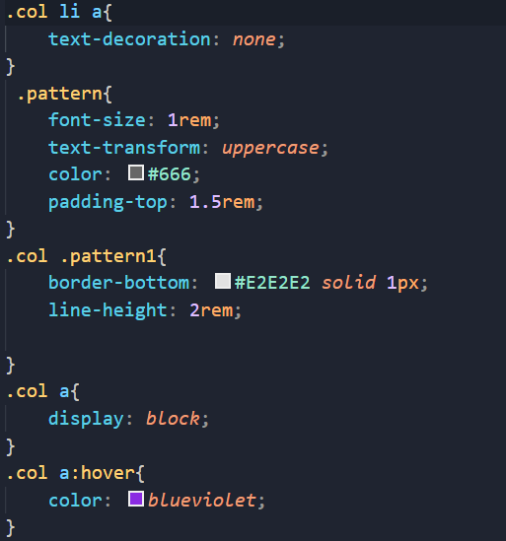

4 HTML for describing the structure of a web page

HTML is the authoring language used to create documents on the web. It is used to define the structure and layout of a web page, how a page looks, and any special functions. HTML does this by using what are called tags that have attributes. For example, <p> means a paragraph break. As the viewer of a web page, you don't see HTML; it is hidden from your view. You see only the results.

5. The summary:



# Reference:

1. The History of HTML and How It Revolutionized the Internet, viewed 2 December 2021, <https://www.thoughtco.com/history-of-html-1991418>
2. The Benefits Of Cascading Style Sheets, viewed 2 December 2021, <https://vanseodesign.com/css/benefits-of-cascading-style-sheets/>
3. HTML vs CSS, Priya Pedamkar, viewed 2 December 2021, <https://cdn.educba.com/academy/wp-content/uploads/2018/06/HTML-vs-CSS.jpg.webp>
4. HTTPModule Event Execution Order?, viewed 2 December 2021, <https://stackoverflow.com/questions/441421/httpmodule-event-execution-order>
5. Working With HTTP Verbs, SURJEET YADAV, Apr 30 2013, viewed 2 December 2021, <https://themeisle.com/blog/what-are-http-error-codes/>
6. Notes on the format of HTTP requests and responses, September 21, 2020, viewed 2 December 2021, <https://docs.citrix.com/en-us/citrix-adc/current-release/appexpert/http-callout/http-request-response-notes-format.html#:~:text=Format%20of%20an%20HTTP%20Response%20Format%20of%20an,message%20line%29%20contains%20the%20HTTP%20method%20and%20target>.
7. Difference Between Client and Server, viewed 2 December 2021, <http://www.differencebetween.net/technology/difference-between-client-and-server-2/>
8. What is a Client? What is a Server? And What is a Host?, May 9, 2014, LearnTomato, viewed 2 December 2021, https://learntomato.flashrouters.com/what-is-a-client-what-is-a-server-what-is-a-host/